Too Many Eyes / *UI*

System Design Document

# Changes

## Version 0.1

Editor: Alexander Bowerman

12/12/2022

* Document Created.
* Introduction, Design Goals, and Behaviour descriptions added.

## Version 0.2

Editor: Alexander Bowerman

13/12/2022

* High Level Design, Mid Level Design UML added.

## Version 0.3

Editor: Alexander Bowerman

14/12/2022

* High Level Design, Mid Level Design descriptions added.
* Case View Steps & Screenshots added.

# Introduction

*This document details the design and purpose of a UI system designed for Too Many Eyes. Designed for the Blight Brew Game, the document will cover;*

*⦁* *Usage for the designers.*

*⦁* *UML for the Programmers.*

# Design Goals

The goal of this system is to;

* *Have an immersive User Interface*
* *Be intuitive and accessible for any player*
* *Give the player control over their play experience*

# Behaviour

*The UI System is a custom User Interface system, designed for ease of use for the player. The UI System acts as a visual component for the player to interact with the game world, change settings, navigate levels, etc.*

* *The* ***Main Menu*** *– The first UI component they player is exposed to, allows the player to:*
  + *start a new game*
  + *access the* ***Settings Submenu***
  + *view the* ***credits*** *or* ***quit the game***
* ***The Settings Submenu*** *– The game settings menu. Allows the player to:*
  + *Change Video Settings*
  + *Change Audio Settings*
  + *Change Control Settings*
* ***The Pause Menu*** *– Accessed by the player by pausing the game. Allows the player to:*
  + *Resume Game*
  + *Save/Load game*
  + *Access the* ***Settings Submenu***
  + *Quit to main menu*
* ***The Journal*** *– The Journal Widget is part of the HUD and is activated by the player opening their map or backpack. The Journal will then open the corresponding Widget.*
* ***The Backpack*** *– The backpack will display the current items in the player’s inventory and quick slots. It will also allow the player to organize their inventory and quick slots*
* ***The Map*** *– Displays the map of the world*
* ***The HUD*** *– Displays the* ***Time Widget,******Quick Slots Widget,*** *and* ***Focus Text***
* ***Time Widget*** *– Displays the current world time*
* ***Quick Slots Widget*** *– Displays the 3 Quick slots*
* ***Stamina Bar*** *– Displays player’s current stamina in world space*
* ***Focus Text*** *– Displays the information of the object the player is looking at*

# High Level Design

* Player system - the system is our core system and is what the player interacts with to use all our other systems.
* Locomotion system - an advanced movement system we’re using to give us more control over the players movement. This gives us variables we can control, such as stamina, and additional functionality, such as climbing and vaulting.
* Potion system – a system meant to be easy to use for designers. The system allows for the designers as much freedom as possible, while giving the coders a minimal amount of updating to do. This is the main system the player will use to complete puzzles and generate income.
* Inventory system – a system meant to be easy to use for designers. The system allows for the designers as much freedom as possible, while giving the coders a minimal amount of updating to do. The system works as a container to hold items that the player collects. This includes the players backpack, as well as storage containers around the world.
* Resource system – a system meant to be the first of the steps for the player to generate income. This system gives the player ways to harvest materials and shows off behavioural logic for when the system is used.
* Crafting System – the system in between the Resource system, and the Shop/Potion systems, in terms of actual gameplay. This systems job is to refine the resources the player gathers into other items or potions for use in one of the other systems.
* Shop system - a system to generate income, and allow for the player to improve. The system interfaces with AI, the player, and Storage objects, to give the player a way of selling items to NPC’s. This can have numerous effects on the AI and is the primary source of income, a necessary resource for improving the players arsenal, and serves to break the monotony of just grinding for resources.
* AI System - The system dealing with the NPC’s in the world, including fauna. The system interfaces with the shop system, allowing for NPC’s to be customers, as well as gives the AI their logic for movement, interaction, and anything else.
* Economy System – A system that goes unseen by the player, changes the value of items based on selling history, value of the local economy, and a degree of randomness. This should make the world feel a little bit more alive, and give the player a reason to continually adjust prices based on customer responses.
* User Interface System – A system used to show, hide, and allow the player to control the Interface. The interface controls almost every system in some way, but mainly through the player.

# Mid Level View

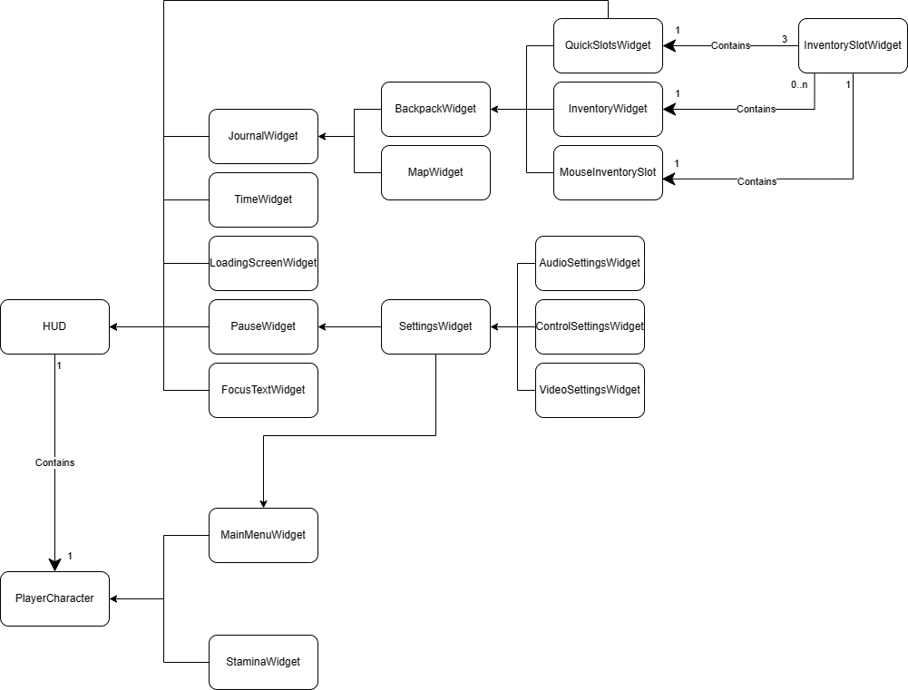

* ***PlayerCharacter*** *– Main Character Class, Contains one HUD, MainMenuWidget, and StaminaWidget*
* ***HUD*** *– Main class for Widgets. Contains:* 
  + ***TimeWidget*** *– A widget that displays the current world time and a progress bar to show the progress of the day*
  + ***LoadingScreenWidget*** *– A widget that displays a circular throbber as a loading icon, accompanied by a game tip.*
  + ***PauseWidget –*** *A widget that covers the entire viewport and displays button options to the player:*
    - *Resume Game Button*
    - *Save/Load Game Button*
    - *Settings Button (Opens* ***SettingsWidget****)*
    - *Quit to Main Menu Button*
  + ***SettingsWidget –*** *A widget that the player can use to customise game settings. The three components are:*
    - ***AudioSettingsWidget –*** *A widget that the player can use to customise audio settings.*
    - ***ControlSettingsWidget –*** *A widget that the player can use to customise control settings.*
    - ***VideoSettingsWidget –*** *A widget that the player can use to customise video settings.*
  + ***FocusTextWidget –*** *A widget that displays a brief description of the object the player is looking at.*
  + ***QuickSlotsWidget –*** *Contains three* ***InventorySlotWidget***
* ***MainMenuWidget–*** *A widget that covers the entire viewport and displays button options to the player:*
  + *New Game Button*
  + *Load Game Button*
  + *Settings Button (Opens* ***SettingsWidget****)*
  + *Quit to Desktop Button*
* ***Journal–*** *A widget that contains the* ***BackpackWidget*** *and* ***MapWidget***
* ***BackpackWidget–*** *A widget that contains:*
  + ***InventoryWidget****,* ***–*** *Contains variable amount of* ***InventorySlotWidget***
  + ***QuickSlotsWidget –*** *Contains three* ***InventorySlotWidget***
  + ***MouseInventoryWidget –*** *Contains one* ***InventorySlotWidget***
    - ***InventorySlotWidget*** *– A widget that displays the sprite, and quantity of an inventory object*
* ***StaminaWidget*** *– Displays the player’s current stamina, beside the player character object in the world*

# Logical View

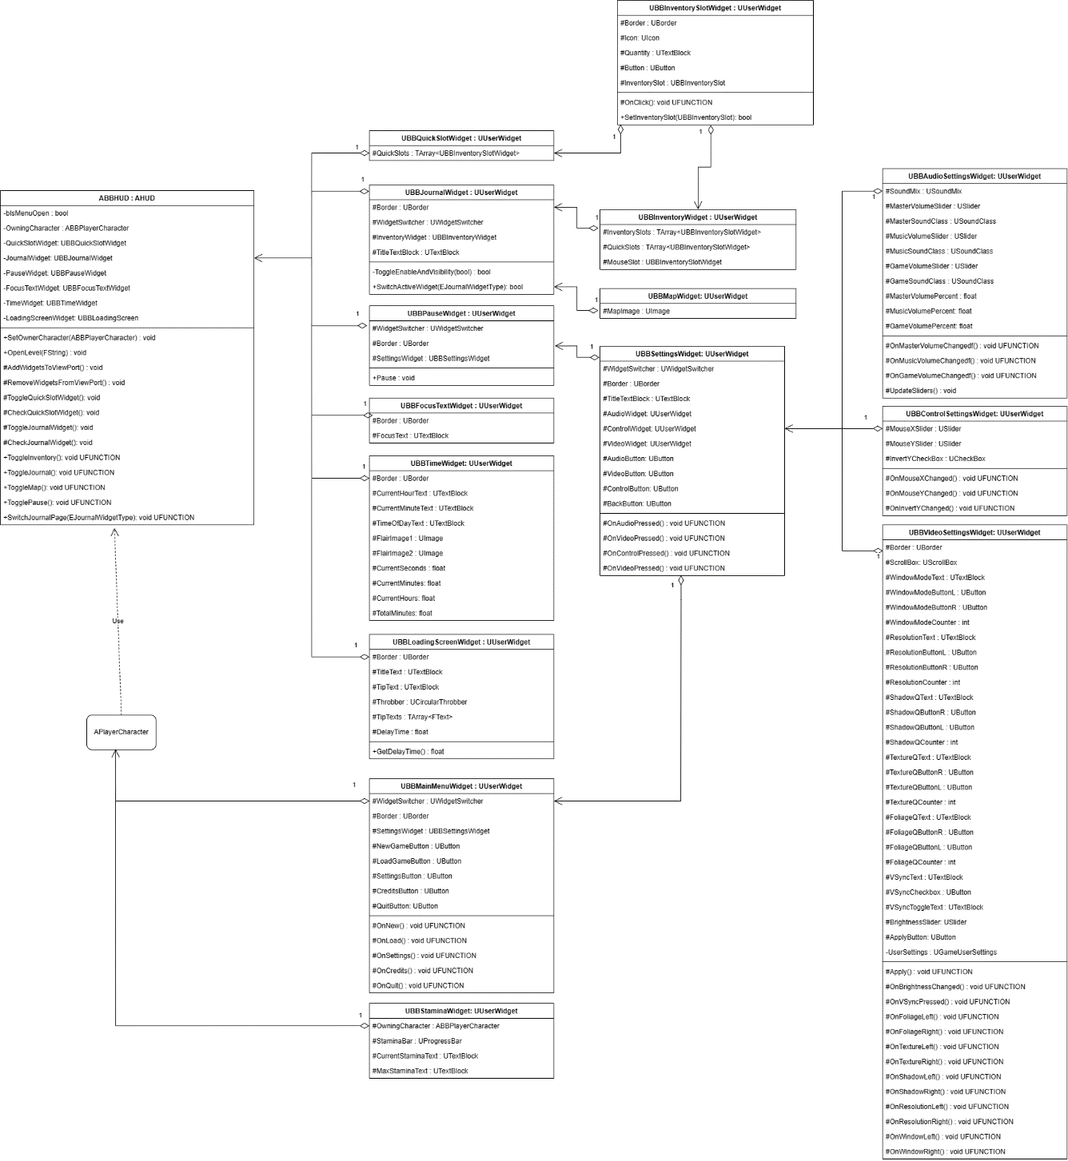

# Process View

## Pause Screen & Settings Screen

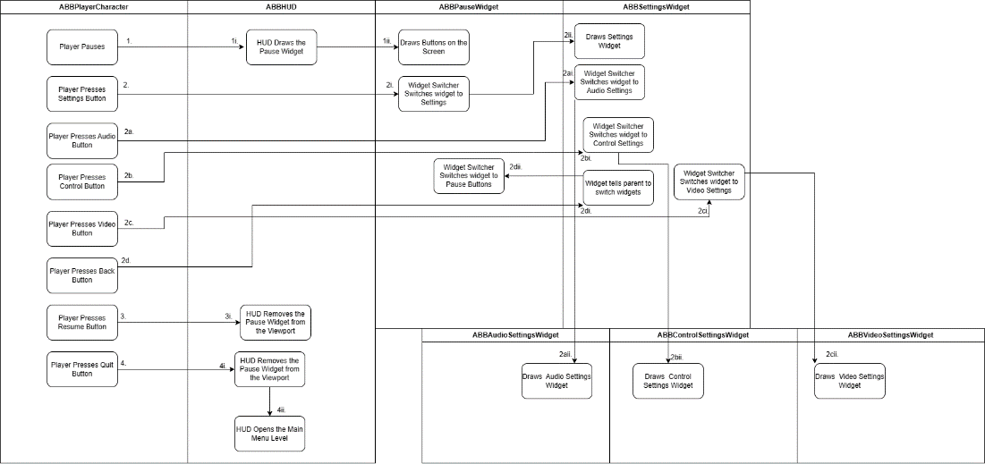

## Audio Settings, Control Settings, and Video Settings

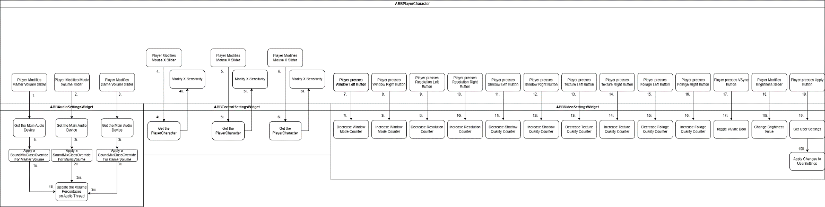

## Main Menu Screen

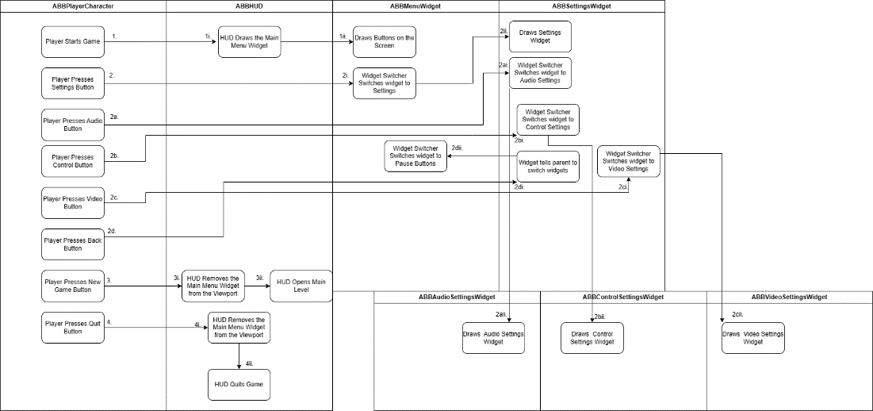

# Use Case View

## Creating a Widget Blueprint

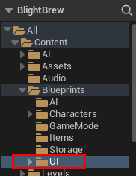

* Go to BlightBrew/Content/Blueprints/UI
* Navigate to the folder of the widget you want to create (in this example Journal is being created)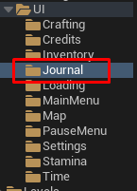

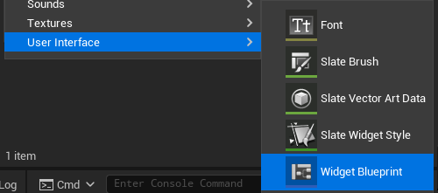

* Right Click and select User Interface > Widget Blueprint

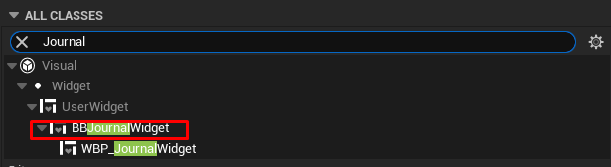

* Search the Widget you are creating
* Select the C++ Class for the Widget

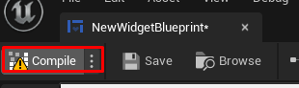

* Enter the blueprint and press compile

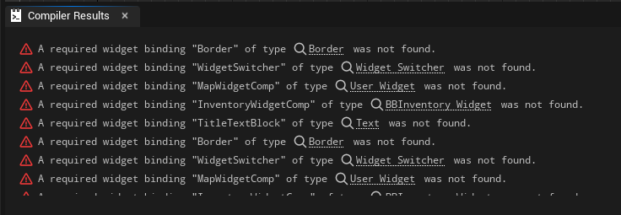

* The compiler say what elements to add